Databricks Assignment [28-12-2023]

By Karthikeyan K R

**Setting up my Azure Lab:**

MakeMyLabs Interface

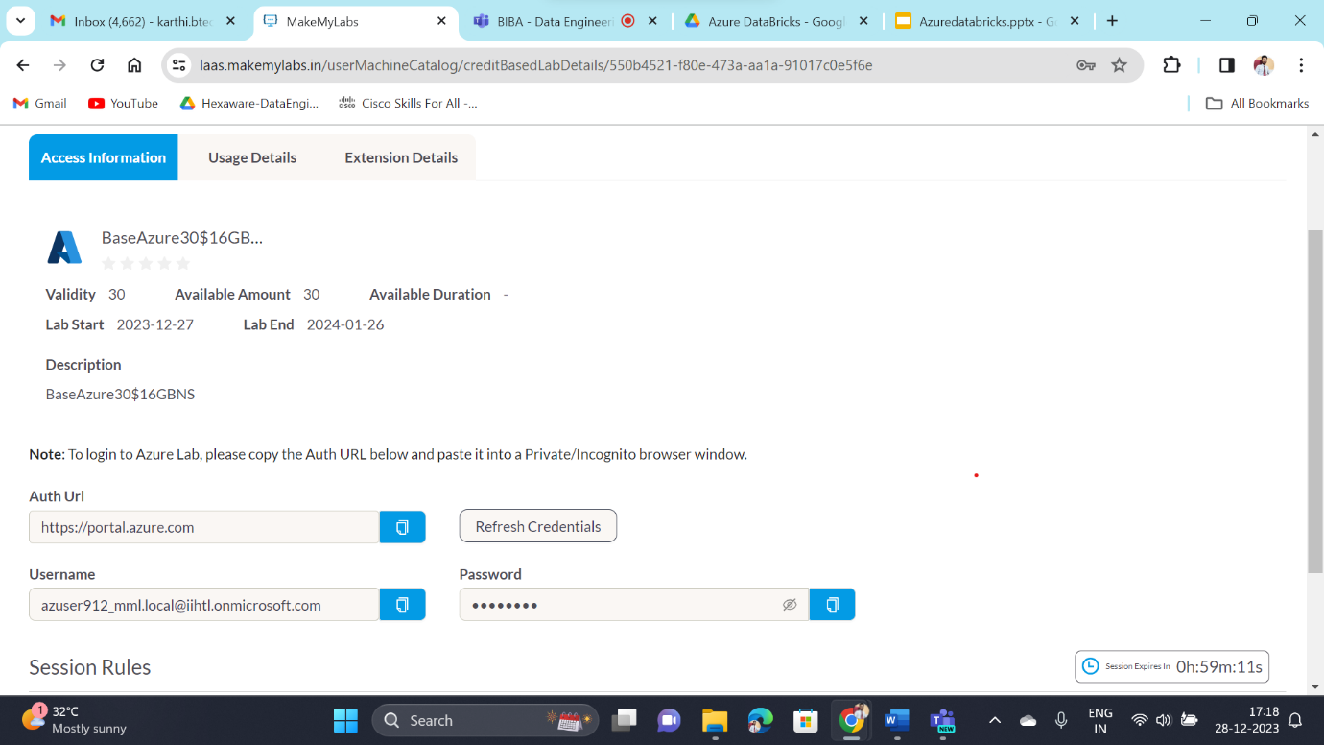

Azure Portal

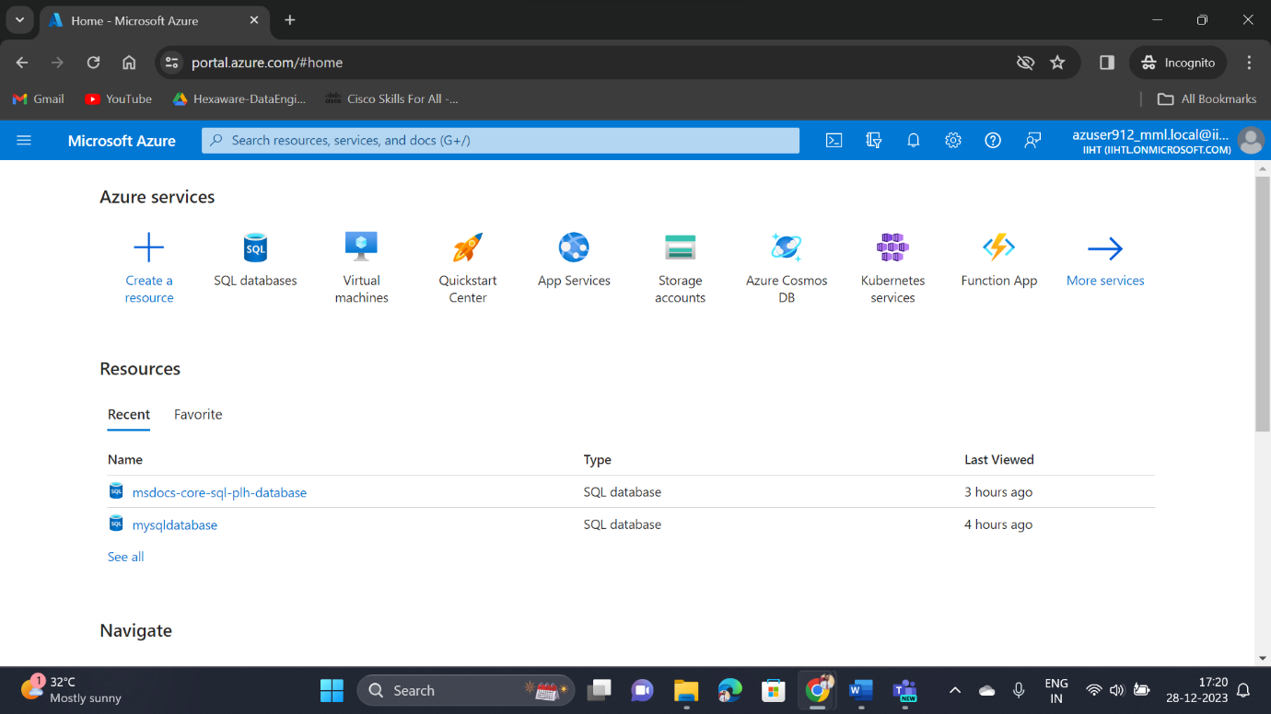

**Azure Databricks**

Azure Databricks is a service provided by Microsoft Azure that helps organizations process and analyze large volumes of data efficiently.

**Apache Spark**

Apache Spark is an open-source, distributed computing system that can process large amounts of data quickly.

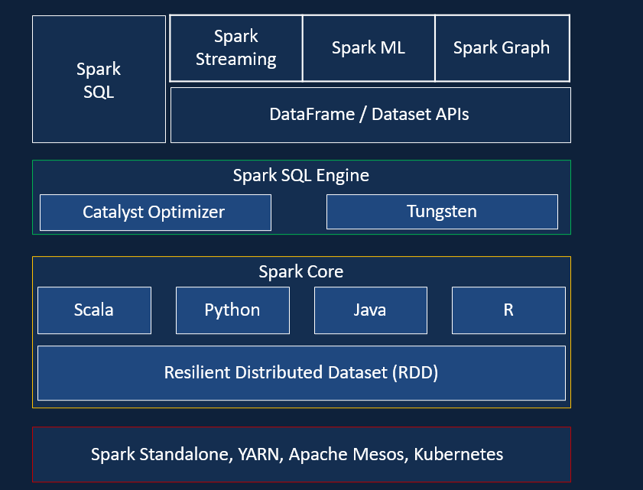

**Databricks**

Databricks simplifies the process of working with big data by offering a unified platform that combines data processing, machine learning, and collaborative tools.

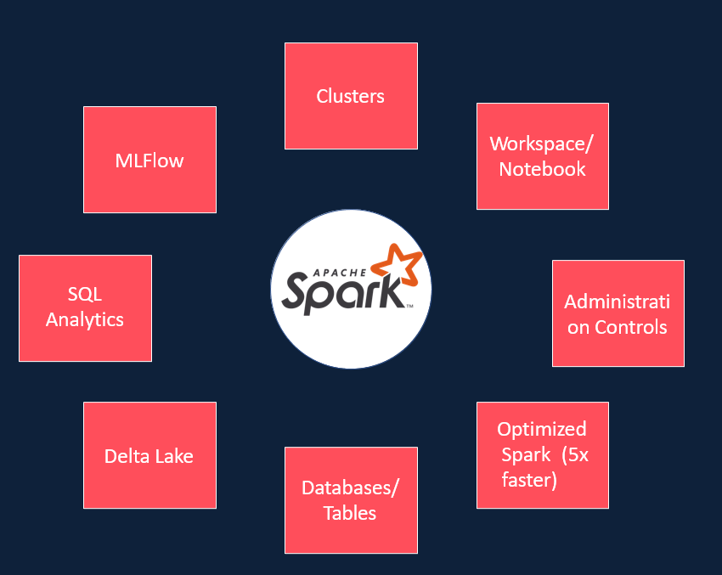

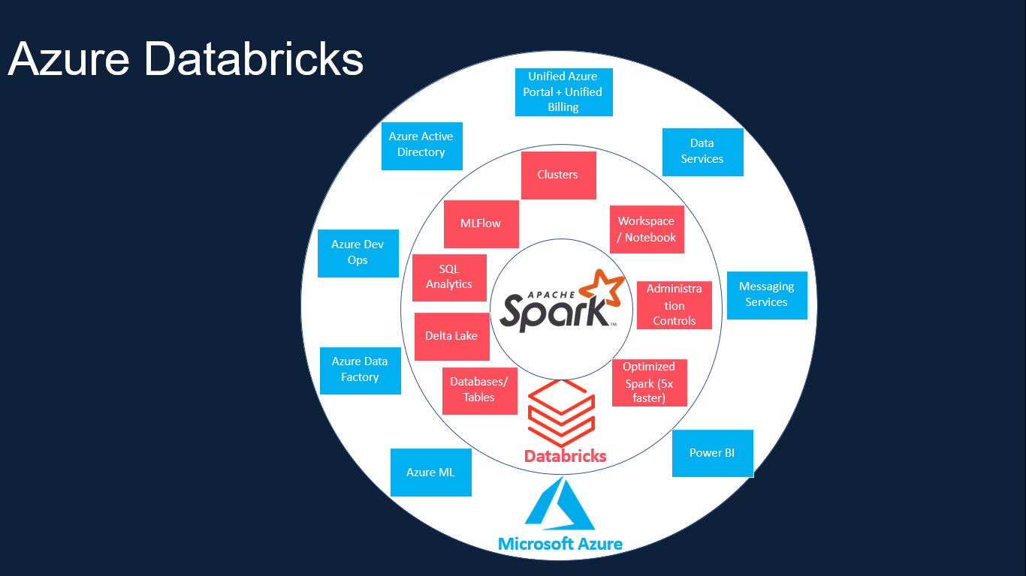**Azure Databricks**